Autumn Term 2026 Newsletter 2
“Therefore encourage one another and build each other up, just as in fact you are doing.” 1 Thessalonians 5:11
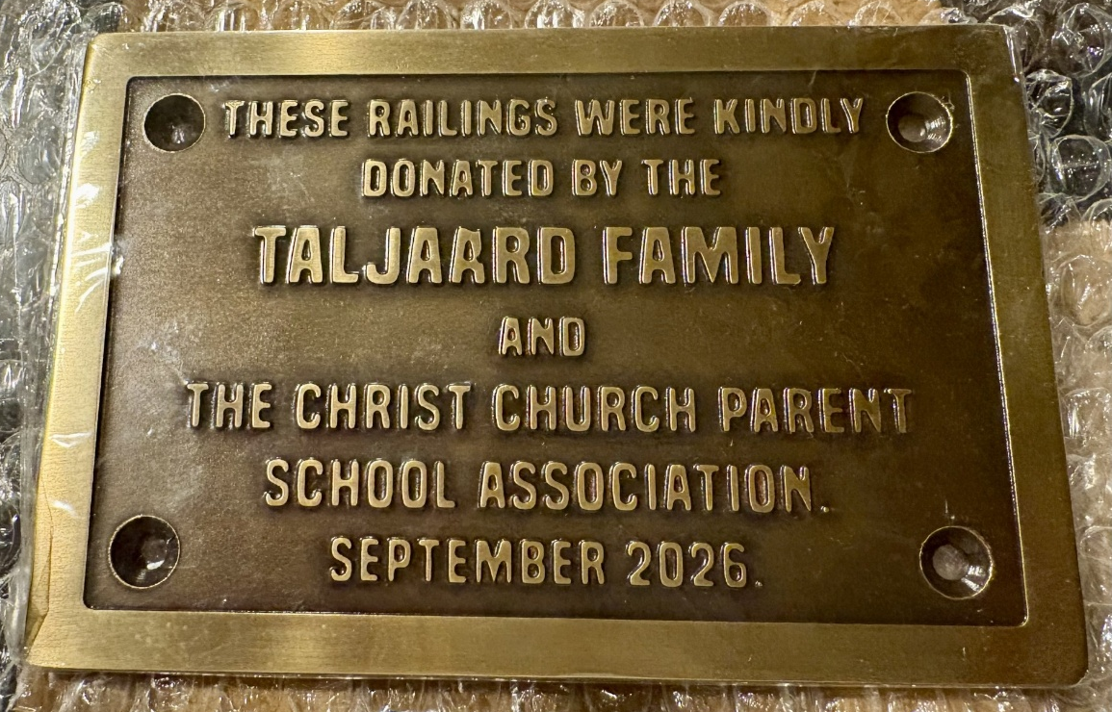
Dear Parents & Carers,
The children have settled back into the new academic year really well, and we have a number of exciting events and important dates coming up.
Please take a few minutes to read through this newsletter and make a note of the events taking place over the coming weeks, leading up to half term.

Upcoming Events
- Tuesday 6 October, 2.15pm – Year 4 Harvest Service
Year 4 parents are warmly invited to attend.
- Wednesday 7 October – Individual school photographs
- Wednesday 7 October, 7.30pm – PSA AGM, in the school hall
- Friday 9 October, 7.00pm – EYFS & KS1 SchoolCloud Parent Consultation bookings open
- Wednesday 14 October, 9.00am – Year 1 Mastering Number Workshop
Parents are warmly invited to attend.
- Thursday 15 October, 9.00am – Year 2 Mastering Number Workshop
Parents are warmly invited to attend.
- Tuesday 20 & Wednesday 21 October – EYFS & KS1 Parent Consultations
- Thursday 22 & Friday 23 October – Staff training days
School closed to children.

Railings and Wall Project
You will have seen the gradual progress of the railings, gates, electrical entry system and associated groundworks throughout September. We are delighted to announce that this longstanding project is now complete.
This has been a significant project for our school, and we would like to take this opportunity to recognise the incredible support we have received from our parent community.
A huge THANK YOU to the Taljaard family, who made an extremely generous donation to cover the shortfall in funding for this project, and to our PSA, who also made a significant contribution from their fundraising.
The additional security provided by the new railings, gates and entry system gives our staff great reassurance and, most importantly, helps us to ensure that our children remain safe and secure while they are in school.
We are incredibly grateful to everyone who helped make this possible.

Wildlife Garden
With the completion of the railings, our Wildlife Garden is now a safe and secure part of the school site. We were therefore delighted to remove the Heras fencing and, at last, allow the children to enjoy this wonderful space.
Both the garden and the children are flourishing!
A huge THANK YOU to every parent who has, at some point, weeded, watered, built, moved, removed, carried or planted something in the garden. It has taken many hours of hard work and commitment to bring the vision to life, and we are incredibly grateful for everyone's support.
A very special THANK YOU goes to Claire Donnelly-Dennis, who dedicated more than a year to helping us plan and deliver such a beautiful Wildlife Garden for our children.
Claire supported Mrs Young and me through many moments when we wondered whether we would ever get there — from securing funding and arranging deliveries to finding the right resources at the right price and tracking down volunteers with the skills we needed. Claire consistently rallied, encouraged and worked incredibly hard to keep the project moving forward.
We would also like to thank the other members of our Playground Working Group, who supported the project from its earliest stages through to completion. In particular, our thanks go to Mrs Young and Charlotte Pratt for their dedication and commitment.
So many other wonderful people have played a part in making this project a reality that it would be impossible to name everyone individually. Please know how much your support has been appreciated.
And we are not finished yet! In time, we hope to develop the area closest to the vicarage further, creating a small woodland area and a seating circle for small-group outdoor learning and activities.

Reading at Home
A huge thank you to all those parents and carers who have volunteered their time to hear children read in school. I am pleased to say that we now have enough volunteers to support our reading provision.
Reading takes place in school in many different ways throughout the children's time with us. However, this cannot replace the valuable one-to-one reading time we ask parents and carers to provide at home.
The opportunity to read regularly, ideally every day, is an essential part of developing confident and fluent readers. It is the one home-learning activity that we encourage above all others.
Please continue to work with us by making reading at home a priority. Your time and encouragement make a real difference.

New School Catering
Following the initial transition to our new catering supplier, we are pleased to see the children enjoying the carefully considered menu now available to them.
The School Food Standards set clear requirements for the range and nutritional balance of food provided in schools, including the provision of fruit and vegetables, starchy foods, protein sources and dairy, alongside limits on foods high in fat, sugar and salt.
The updated primary school portion guidance introduced in September 2026 is also reflected in our school meal provision.
We are delighted that the children are now able to enjoy freshly prepared, hot meals each day, with a menu designed to provide a balanced and nutritious lunchtime meal.

And Finally…
Today, we say goodbye to a much-loved member of our staff team, Mrs Johnson, who leaves us after being part of the Christ Church community for an incredible 21 years.
Mrs Johnson's connection with Christ Church began as a parent, with all four of her children attending our school. Six years ago, she then joined our office team, where she has supported children, families and staff with her characteristic calmness, kindness and efficiency.
We are very sad to see Mrs Johnson leave and will certainly miss having her as part of our team. However, we are pleased that she will now have more time to focus on her family.
We very much hope that she will return to Christ Church from time to time — perhaps as a volunteer, or simply to drop off some of her wonderful cakes!
Thank you, Mrs Johnson, for everything you have given to our school community over the years. You will be very much missed by everyone at Christ Church School, and we wish you every happiness for the future.
Yours sincerely,
Mrs Allaway
Head of School

