Ideas for 2025-206 Eco and School Council Project
By Jess, Natalia and Monty

How can we make a difference to the environment in our school?
We learnt about how many aspects that can be worked upon, support such a wide range of insects and animals, as well as helping the wellbeing of the people involved.

Some ideas we have taken away from our time spent on Woodoaks farm:

How can we increase planting in our school with limited ‘green’ area to develop?

Using tyres we can create areas to grow, recycling the tyres, whilst making more plants for the wildlife and us to enjoy.
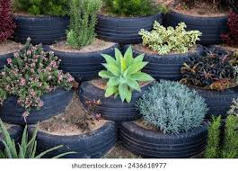
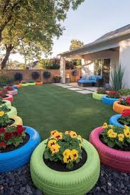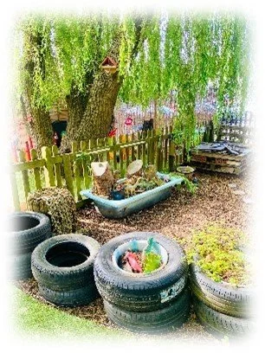

Planting
Tyres, making growing areas for each class, or use the tyres to make a quiet space for children to enjoy outside the Y5/ Nursery area.
Herbs that grow in winter garlic,rosemary,oregano,sage

What would grow in tyres?
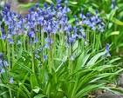
Snowdrops crocus daffodils bluebells
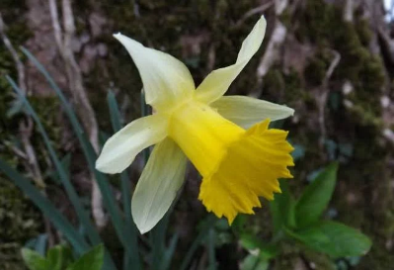
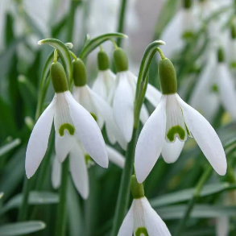
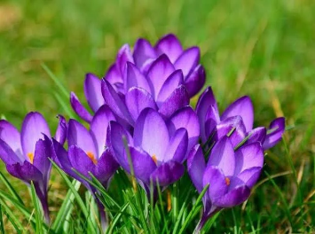
Also wild flower seeds (these will flower in summer)

Eco Council to look in the playground to see if any tyres or raised beds could be added (without impact on the playground)
Look at what we are growing already outside y3/4?

Fruit trees?
Reception garden has an apple tree and space to grow. Y6 to help use this area to grow food items of their choice/ research etc.

Wildlife
Year 5 visit the farm to make birdboxes. Arrange for additional to be made.
Survey the grounds for how many and where

Bug hotels: Can we make some of these for the grassy area, new quiet garden, Nursery/ reception classes?

To do
- Letter to parents if they can plant a few bulbs for us now, so we can make the area and add the bulbs in
- Fundraisers for resources
- Ask for support Mrs Young/ Mrs Cuzub on what to plant when
- Meeting with school council to share the project/ then school assembly
- Invite Woodoaks in to school for assembly
- School fundraising this year: use Woodaks as our charity?

